1. HOME Page:
Slightly Reduce Size of LOGO (AICTE, NBA, NAAC)
In SCROLLING: Increase distance between Welcome to SREC and paper submission deadline

2. ABOUT Page:

About SREC
The Santhiram Engineering College (SREC), established in 2007, is dedicated to fostering academic excellence and research innovation. Santhiram Engineering College (SREC) is sponsored by M/s Sri Shirdi Sai Educational Academy, Nandyal. The institution is established under the able guidance of Dr. M. Santhiramudu, Chairman in the year 2007 with a noble motto “Education for peace and progress”. SREC is approved by AICTE, New Delhi: Recognized by UGC under 2(f) and 12 (B): Permanently Affiliated to JNTUA, Anathapuramu: Certified to an ISO 9001:2015. The institute is accredited by NAAC with ‘A’ grade and NBA. The college is ranked as one of the Best Engineering Colleges of JNTUA. Ananthapuramu.
The college offers various undergraduate programs including Electronics and Communication Engineering, Computer Science and Engineering, CSE-AIML, CSE-DS and postgraduate programs (VLSI System Design and Embedded Systems, MBA, MCA). The institution has been recognized as a Research Center by Jawaharlal Nehru Technological University (JNTU), Anantapur. This recognition allows the institute to offer Ph.D. programs in various streams in engineering.
About ECE
The department has organized 2 international conferences
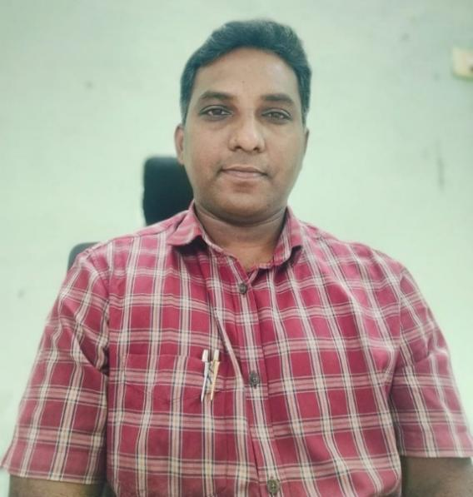

Head of the Department
Dr. Y. Mallikarjuna Rao

3. PAPER SUBMISSION Page:
Remove submission form
Add New guidelines
Add template DOCX
Add CMT link for paper submission: () https://cmt3.research.microsoft.com/ICNDEMAC2026

4. REGISTRATION Page:

Foreign delegates 120 USD 150 USD

Add Department Account details:
HOD-ECE,
SBI A/c No: 33604045975
IFSC : SBIN0010577
Branch: RGMCET, Nandyal

5. TEAM Page:

General Chairs:
Dr. M. Venkata Subramanyam, Santhiram Engineering College, Nandyal, Andhra Pradesh, India
Dr. Shaik Asif Hussain, Middle East College, Muscat, Oman

Steering Committee:
IEEE Hyderabad Section to nominate steering committee members
Dr. Y. Mallikarjuna Rao, Santhiram Engineering College, Nandyal, Andhra Pradesh, India
Prof. Isabelle Bloch , Telecom Paris Tech Saint Mary’s University, France
Prof. FerranMarqués, UniversitatPolitècnica de Catalunya, Spain
Dr. M. Y. Veeresh, Santhiram Engineering College, Nandyal, Andhra Pradesh, India
Prof. Dato’ Ir. Jamaludin Bin Non, Dean, School of Engineering and Built Environment Lincoln University College, Malaysia

Technical Program Committee chair:
Prof. Y.Padma Sai, Chair SPS, IEEE Hyderabad Chapter, Hyderabad, India
Prof. T. Ramashri, S.V.University College of Engineering, Tirupati, India.

Technical Program Committee:
IEEE Hyderabad Section to nominate Technical Program Committee members
Prof. Aaron Stillmaker, Lyles College of Engineering, California State University, Fresno
Prof. Dr. Divya Midhunchakkaravarthy, Director, Center for Postgraduate Studies (CPGS), Lincoln University College, Malaysia
Prof. Dr. Midhunchakkaravarthy, Dean, School of AI Computing and Multimedia, Lincoln University College, Malaysia
Prof. B. Alekya Himabindu, Santhiram Engineering College, Nandyal, Andhra Pradesh, India
Prof. Erfan Abbasian, Babol Noshirvani University of Technology, Mazandaran, Iran.
Prof. YannGousseau, Telecom Paris Tech, paris
Prof. Nikhil Jayakumar, Texas A&M University, College Station, TX
Dr. Jorge Eduardo Rico Brieva, Universidad Panamericana Mexico
Prof. Atul Negi, Professor, University of Hyderabad, Telangana
Prof. Siva Rama Krishna Vanjari IIT HYD, India
Prof. P.Srinivasa Rao, IIT Dhanbad, Jharkhand
Dr. Nagini Macha, Senior Scientist, SATHI-CISCoM Centre, IIT Hyderabad
Prof. Srinivasulu Jogi, NIT-Trichy, India
Prof. V. Ramesh Kumar, IIIT-Sri City, Chittoor, Andhra Pradesh, India
Prof. Manoj kumar mujumder, IIIT-Naya Raipur, India
Prof. M. Satish, NIT-Warangal, India
Prof. B. Naresh Kumar Reddy, NIT-Trichy, India
Prof. B. Anuradha, SVU, Tirupati, Andhra Pradesh, India
Prof. D. Vishnu Vardhan, JNTUA, Andhra Pradesh, India
Prof. V. Vijaya Kishore, KSRM, Kadapa, Andhra Pradesh, India
Prof. Vaddi Ramesh, SRM University, Andhra Pradesh, India
Prof. Bujjibabu Nannepaga, Andhra Loyola College, Vijayawada, Andhra Pradesh, India

Organizing Committee chairs:
Dr. N. Praveen Kumar, Santhiram Engineering College, Nandyal, Andhra Pradesh, India
Dr. K. Rajkumar, Santhiram Engineering College, Nandyal, Andhra Pradesh, India
Dr. S. Javid Basha, Santhiram Engineering College, Nandyal, Andhra Pradesh, India

Finance Committee Chairs:
Prof. S. Rambabu, Santhiram Engineering College, Nandyal, Andhra Pradesh, India
Prof. V. Sankarnath, Santhiram Engineering College, Nandyal, Andhra Pradesh, India

Publicity Committee Chairs:
Prof. G. Sowmya, Santhiram Engineering College, Nandyal, Andhra Pradesh, India
Prof. V. Nagamani, Santhiram Engineering College, Nandyal, Andhra Pradesh, India
Dr. Erfan Abbasian, Babol Noshirvani University of Technology, Mazandaran, Iran.
Dr. Acosta, Oscar Université de Rennes Campus de Beaulieu, Rennes, France
Dr.B.Vivekanandam, Pro Dean, School of AI Computing and Multimedia, Lincoln University College, Malaysia

Publicity Committee:
Prof. P. Mary Swetha, Santhiram Engineering College, Nandyal, Andhra Pradesh, India
Prof. P. Surendra Babu, Santhiram Engineering College, Nandyal, Andhra Pradesh, India
Dr. Aditya Japa, Ulster University, Northern Ireland
Dr. Altuve, Simon Bolivar University,Venezuela
Julia A Schnabel, University of Oxford, UK
Dr. Jianfei Liu, Duke University Medical Center, USA
Mr. S. Munnawar, Santhiram Engineering College, Nandyal, Andhra Pradesh, India
Mr. N. Sreenivasa Rao, Santhiram Engineering College, Nandyal, Andhra Pradesh, India
Mr. S. Gireesh Babu, Santhiram Engineering College, Nandyal, Andhra Pradesh, India
Mrs. S. Jayamangala, Santhiram Engineering College, Nandyal, Andhra Pradesh, India
Mrs. G. Neelima, Santhiram Engineering College, Nandyal, Andhra Pradesh, India
Dr. Dinesh Rajassekharan, Associate Professor, Lincoln University College, Malaysia
Dr. Ching Joo Jie, Postgraduate Coordinator of AI Technology Engineering Programmes, Lincoln University College, Malaysia
Prof. Dr. Lubna Ali Mohammed, Pro Dean, School of Education, Lincoln University College, Malaysia

Publication Committee Chair:
Dr.C.Kumar, Chair, ComSoc, IEEE Hyderabad Chapter, Hyderabad, India
Dr. S. Javid Basha, Santhiram Engineering College, Nandyal, Andhra Pradesh, India

Publication Committee
Prof. M. Mahesh Kumar, Santhiram Engineering College, Nandyal, Andhra Pradesh, India
Mr. S. Mohammad Eliyas, Santhiram Engineering College, Nandyal, Andhra Pradesh, India
Mr. K. Vinod Kumar, Santhiram Engineering College, Nandyal, Andhra Pradesh, India
Mr.K.Abdul Rahaman, Santhiram Engineering College, Nandyal, Andhra Pradesh, India

Advisory Committee:
Prof. Amit Acharyya, IIT-HYD, Telangana, India
Prof. G. Umamaheswara Reddy, SVU, Tirupati, Andhra Pradesh, India
Prof. K. Venkata Ramanaiah, YVU, Kadapa, Andhra Pradesh, India
Prof. Gábor Székely Swiss Federal Institute of Technology (ETH Zürich), Switzerland
Prof. S. Md. Farooq, Santhiram Engineering College, Nandyal, Andhra Pradesh, India
Prof. B. Seshaiah, Santhiram Engineering College, Nandyal, Andhra Pradesh, India

6. PUBLICATION Page:

In Conference Proceedings
2.All accepted papers will be published in the IEEE Xplore.

1.All accepted papers will be published in ICNDEMAC conference proceedings and in IEEE Xplore.

Indexing and Databases
leading databases, including Scopus, remove this one

Guidelines for Authors
Remove download button

